State-Level, Monthly-Aggregated Daily Maximum Temperature Responses to Climate Change (Nature Data Draft)
Kenneth L. Cox, C. Adam Schlosser, Jennifer Morris, Xiang Gao

Abstract
Though average global temperature is expected to continue to rise, not all areas will experience the same temperature changes. Identifying and understanding which regions will undergo more warming than others is an important factor for adaptation and response measures. Daily maximum temperature is a key metric as it strongly correlates to human health and economic outcomes. We generate and analyze global warming-attributed trends in monthly-averaged maximum daily temperature across all states in the United States using linear regressions, with data drawn from the MERRA2 and ERA5 reanalysis datasets. Comparing which states and months experience stronger warming trends, the distribution is highly heterogenous, with sparse significant trends in February and May giving way to abundant significant warming trends throughout the summer months, especially September. Over the course of the year, Alaska, Utah, New Mexico, Colorado, and Nevada have the highest average warming trends, while Hawaii, Montana, North Dakota, South Dakota, and Arkansas have the lowest. This work assists in identifying the highest-risk regions to near-term warming, enabling policymakers to triage those states that will experience the most drastic extreme-temperature increases.
Table of Contents
State-Level, Monthly-Aggregated Daily Maximum Temperature Responses to Climate Change (Nature Data Draft) 1
Abstract 1
Background and Summary 2
A Web App for Visualization of Average Monthly Maximum, Mean, and Minimum Temperature Trends 8
Methods 10
Webapp 11
Data Records 12
Technical Validation 12
Usage Notes 12
Code Availability 12
References 12
Acknowledgements 15
Author information 15
Ethics declarations 15
Supplementary information 15

Background and Summary
Average global temperature increase as the result of anthropogenic climate change is projected to drive local increases in daily minimum temperature (T_{min}), daily mean temperature (T_{mean}), and daily maximum temperature (T_{max}) (Collins et al. 2013). In turn, these increases have wide-ranging effects on ecosystems (García et al. 2018), electricity usage and the electrical grid (Molina et al. 2023; Gao et al. 2018), and crop productivity (Wheeler et al. 2000), among other areas. Understanding how this increase in average global temperature relates to increases in local temperature is necessary for gauging the impact of these changes and ultimately assessing the benefits of global actions. Moreover, as predictions of global temperature increase carry uncertainty (Lee et al. 2023), it is also important to factor in this uncertainty into predictions at the regional level, and to account for uncertainty originating in policy decisions by analyzing regional temperature responses under different emissions scenarios.
Reanalysis data sets, such as MERRA2 and ERA5, have been used to substantiate past temperature trends and serve as extrapolation to future outcomes. Many reanalysis data sources contain high-resolution records over time periods long enough to capture anthropogenic forcings, making them ideal for studying local responses to global temperature trends (Fujiwara et al. 2017). However, many of these studies adopt a particular focus, examining temperature trends in specific regions like the Mississippi River basin (Tavakol et al. 2020), the Northeast (Hayhoe et al. 2008), Southeast (Powell and Keim 2015), and Midwest (Dai et al. 2016). Studies examining temperature trends across the U.S. (e.g. Portmann et al. 2009, Grotjahn and Huynh 2018) have not reported state-level aggregations for metrics such as daily high and low temperatures, which provide useful summaries for policymakers and the public.
We aim to complement these past studies with a daily analysis of temperature trends in all US states over each month. Using MERRA2 and ERA5 reanalysis data, we relate changes in average maximum (T_{max}), minimum (T_{min}), mean (T_{mean}) daily temperature for each month and state in the United States to global temperature changes over the period 1980-2022 through linear regression models. After separate regressions are done for each dataset, the regression coefficients are combined via an inverse variance-weighted average, returning the best estimate of historical trends according to both datasets. Based on these historical trends, we generate predictions for future warming under a business-as-usual and policy scenario, with data derived from the MIT Earth Systems model (Sokolov et al. 2018).
In the discussion and presentation of the results below, we focus on the results for T_{max}. The choropleth map in Figure 1 displays both the spatial and temporal distributions of the pooled slope (i.e., the warming trend) of T_{max} against the global averaged temperature.
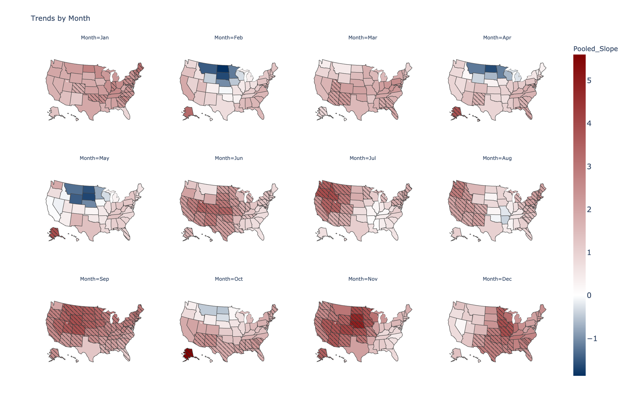
Figure 1. Results from a regression of monthly-averaged maximum daily temperature against global mean temperature (reporting inverse variance-weighted average slope between the ERA5 and MERRA2 datasets). Slopes are displayed for all 50 states in units of degrees of state-level monthly-averaged maximum daily temperature per degree of global mean temperature. Shading represents significance of the slope coefficient at α = 0.05 under a t-test, H₀: $\hat{β}$=0.
The observed warming displays geographic and temporal patterns. The Midwestern states experience very small trends that even slope negative from February-May; North Dakota and South Dakota in May display the sharpest downtrend overall, with approximately 1.6 degrees of cooling per degree of global warming. However, the weakness of the trend from January-April results in the actual magnitude of the trend to be insignificant, as statistical hypothesis testing demonstrates. These trends mostly reverse in the summer and the fall, with South Dakota in November showing a statistically significant warming of 4.8 degrees per degree of global warming. Other areas have less dramatic average intra-year variability. The Northeastern states generally stay within 1-3 degrees of local warming (with April-June as the most notable exceptions), while the Southern states often stay below 2 degrees of local warming (with September and December as the most notable exceptions).
To better characterize the spatial elements of the trends, Figure 2 breaks them down by region. The k-means clustering algorithm, a common unsupervised learning algorithm used to visualize climactic and temperature patterns (Kim and Kim 2023; Carvalho et al. 2016; Sathiaraj et al. 2019), was used to generate the map in Figure 2. The algorithm clustered states based on similarity in trends between months, and we specified the k-means algorithm to find 6 clusters. The clusters overlap somewhat with geographic regions in the US, with cluster 1 roughly corresponding to the Northeast, cluster 5 corresponding to the South and parts of the Midwest, cluster 2 corresponding to the Middle Midwest, cluster 3 corresponding to the West, and cluster 4 corresponding to the Upper Midwest. However, the correspondence in each of these cases is not exact, and Alaska did not fit neatly into any of the other clusters. Supplementary Figure 1 in the Appendix contains two additional plots where the number of clusters was set to 4 and 5, as a test of the robustness of the clusters. Supplementary Figure 2 contains boxplots summarizing the distribution of trends within each cluster.
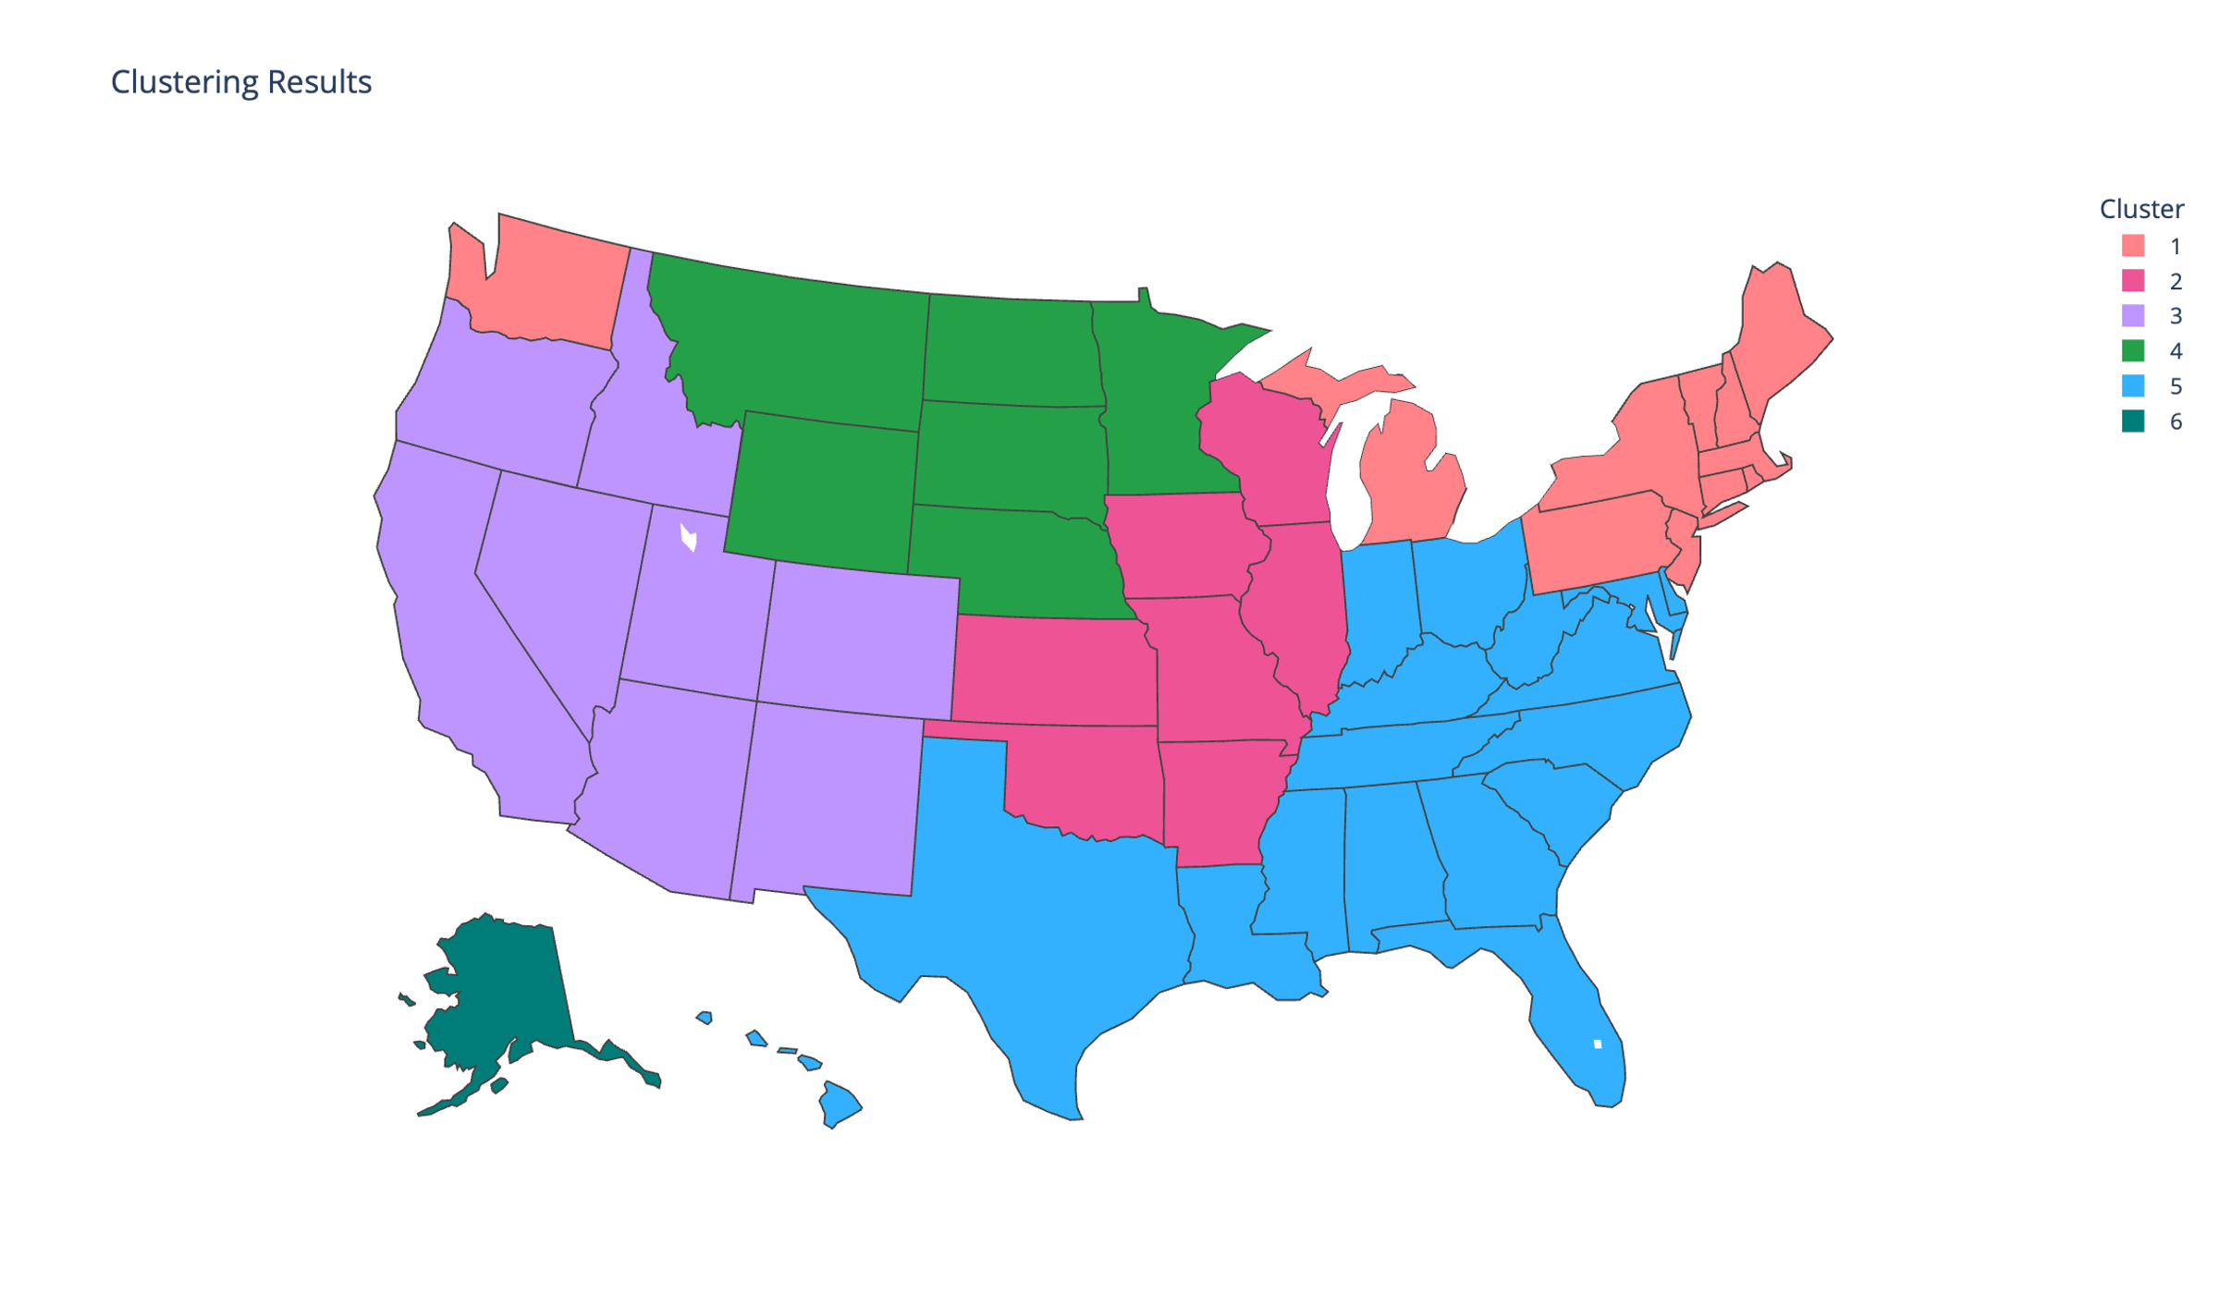
Figure 2. K-means clustering applied to the slopes from the regressions. Each state can be represented as a point in a 12-dimensional space, where each dimension corresponds to that state’s slope in each month of the year. The k-means clustering algorithm partitions the states into (in this case) 6 clusters based on how close each state’s slopes are to the centroid of each cluster, which is updated dynamically for each iteration of the algorithm.
The bar graph in Figure 3 displays the five states with the strongest and weakest trends (averaged over all months) in local daily maximum temperature. Alaska displays the highest historical T_{max} warming, with an average of 2.5 degrees of monthly-averaged maximum daily temperature increase per degree of global warming. The remaining 4 strongest trends occur in states within the same clustering group (shown in Fig. 2). Hawaii displays the lowest average historical warming, at 0.8, but contrary to the strongest trends, the remaining 4 weakest trends do not all occur in the same clustering group (3 of them occur in the same cluster, while the 4th, Arkansas, is distinct from those).
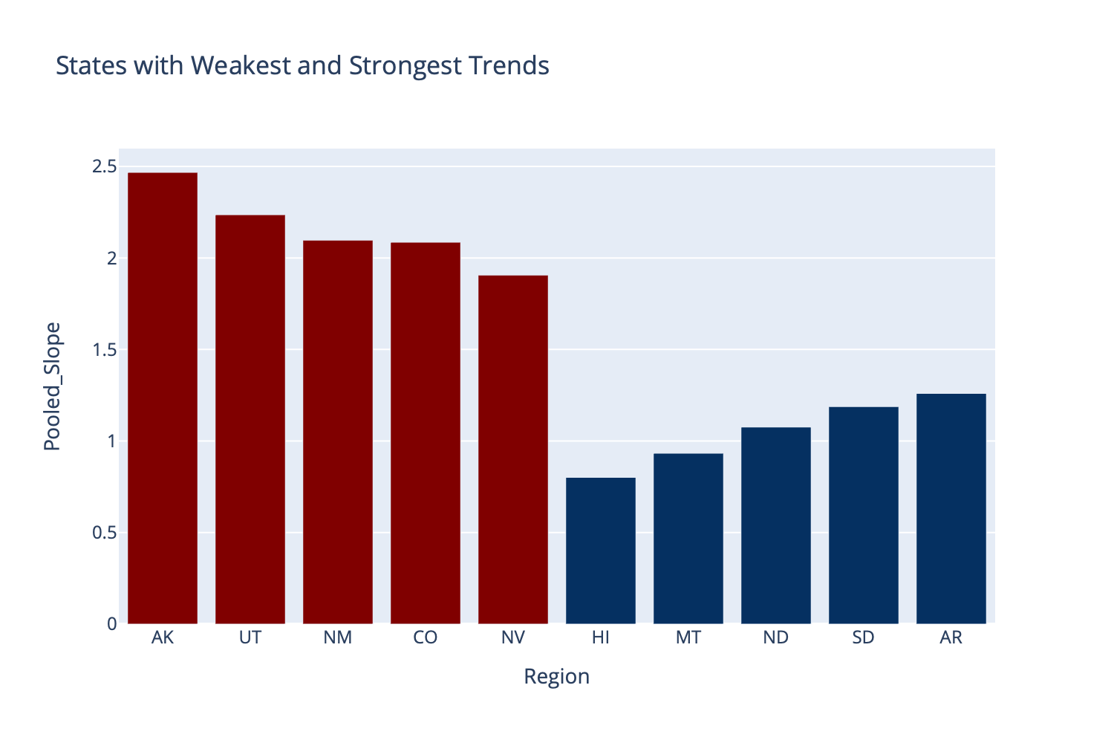
Figure 3. States with the largest and smallest overall warming trends on average. Alaska, Utah, New Mexico, Colorado, and Nevada have the highest average slopes (in red), while Hawaii, Montana, North Dakota, South Dakota, and Arkansas have the lowest (in blue).
Turning to additional spatio-temporal elements of these trends, Figure 4 depicts the resultant distribution of trends by pooling together the estimated trend results from all states for each month. The largest median increase in T_{max} occurs in September (2.63 degrees of local daily maximum warming/degree of global warming), while the lowest occurs in May, with a median warming of 0.74 degrees/degree of global warming. Two month-to-month shifts in the median trend are striking: first, a sharp (greater than 1˚C) drop-off in warming from January to February, and second, a warming spike (greater than 1˚C jump from surrounding months) in September.
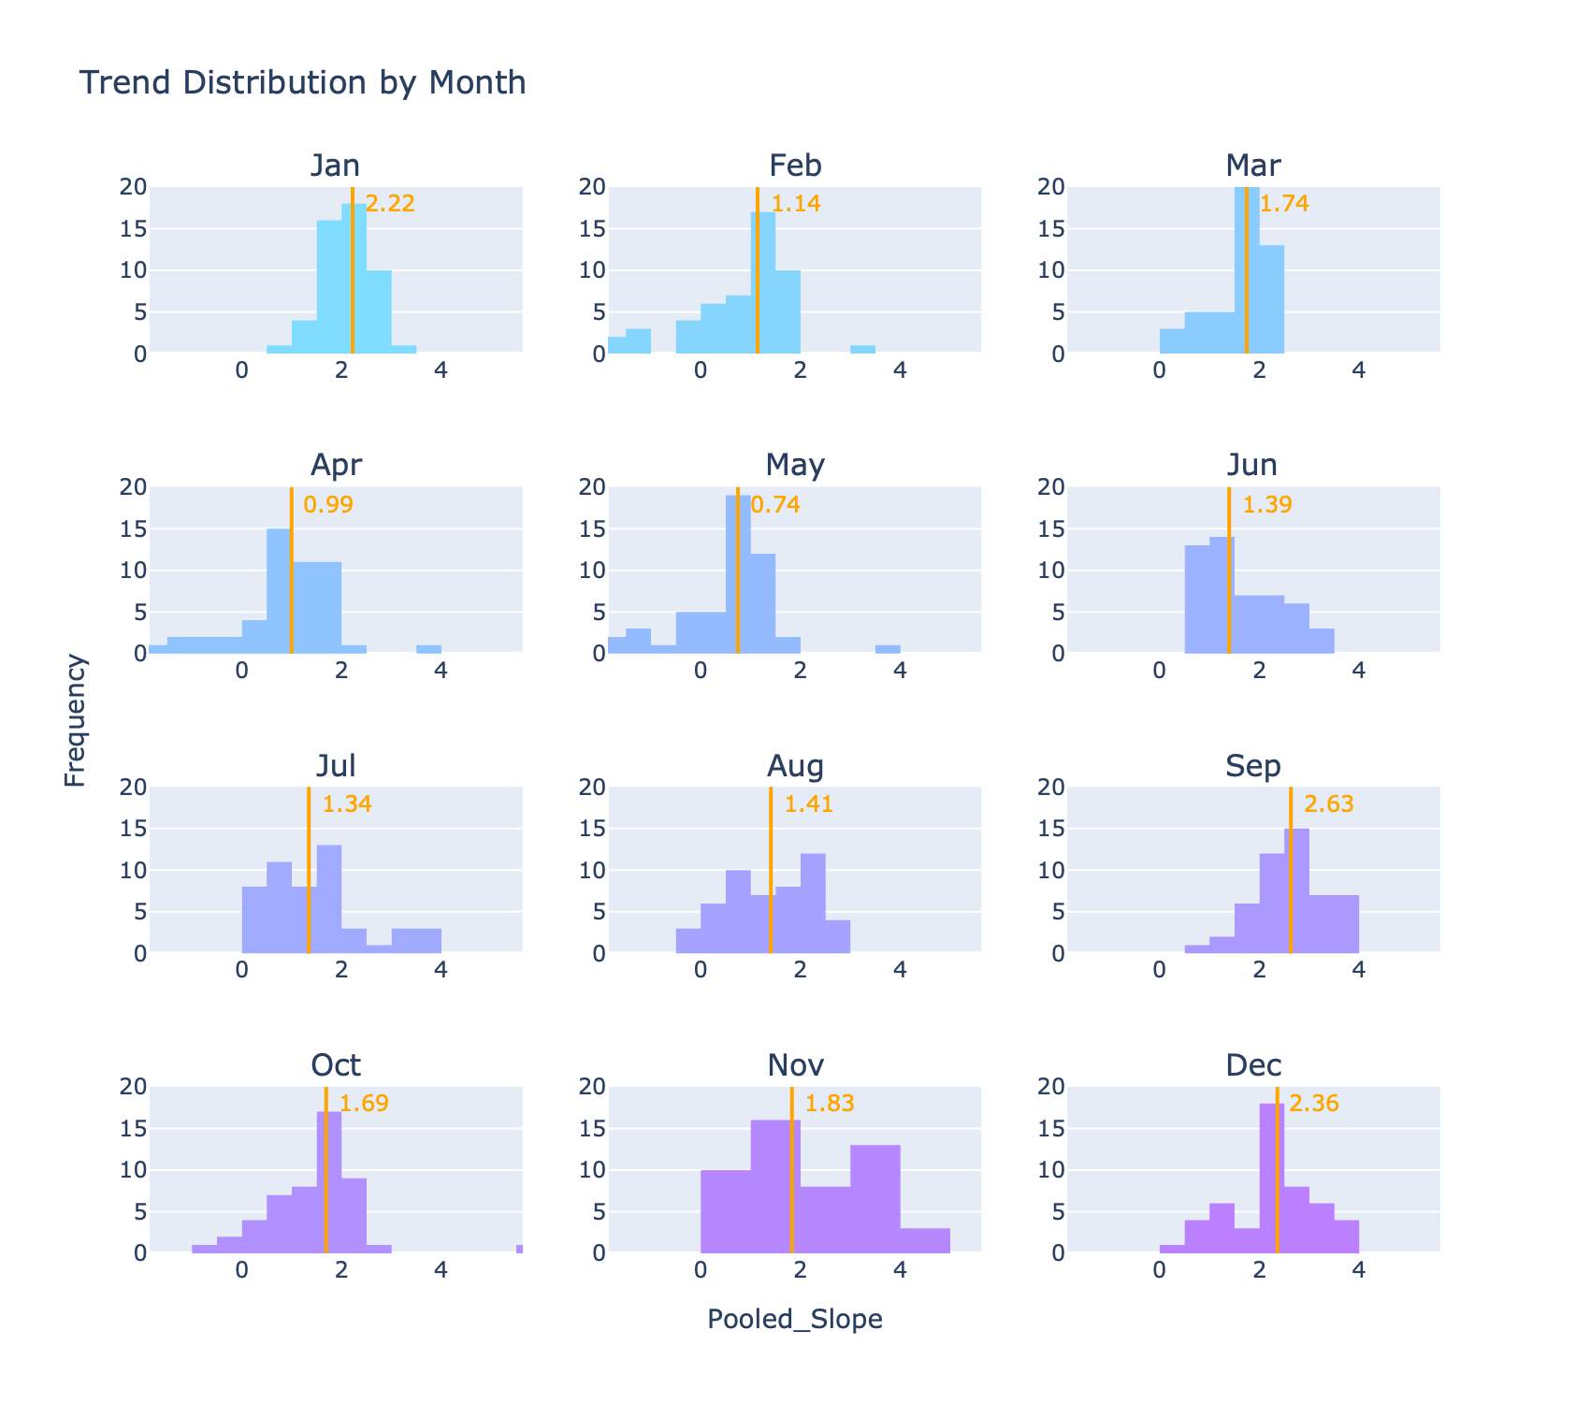
Figure 4. Distributions by month for the slopes of all 50 states. The orange line and text show the medians of the distributions.

A Web App for Visualization of Average Monthly Maximum, Mean, and Minimum Temperature Trends
The results presented in this paper cover overall trends in average monthly maximum temperature for the US. So far, discussion of trends for specific states have largely been absent. To enable ease of visualization of both trends and projections for each state, we present a web app, available to Internet users and without a sign-up requirement. Users can select any state and view historical and projected future temperature data under a business-as-usual scenario and an aggressive mitigation scenario.
The webapp produces figures similar to Figure 6. The projections were generated using two 400-member ensembles of the MIT Earth Systems Model (MESM), one for a business-as-usual scenario, and one for an accelerated actions (policy) scenario. The evolution of the projections of those ensembles is given in Figure 7.
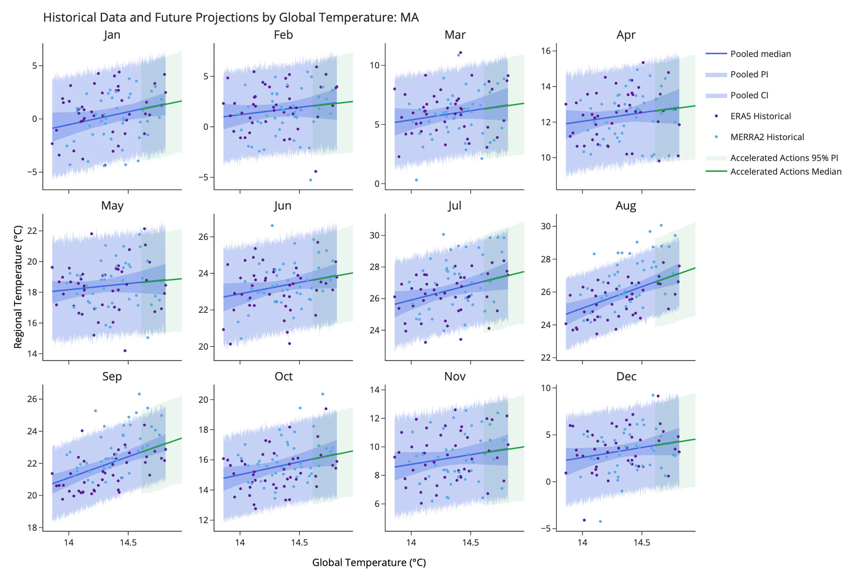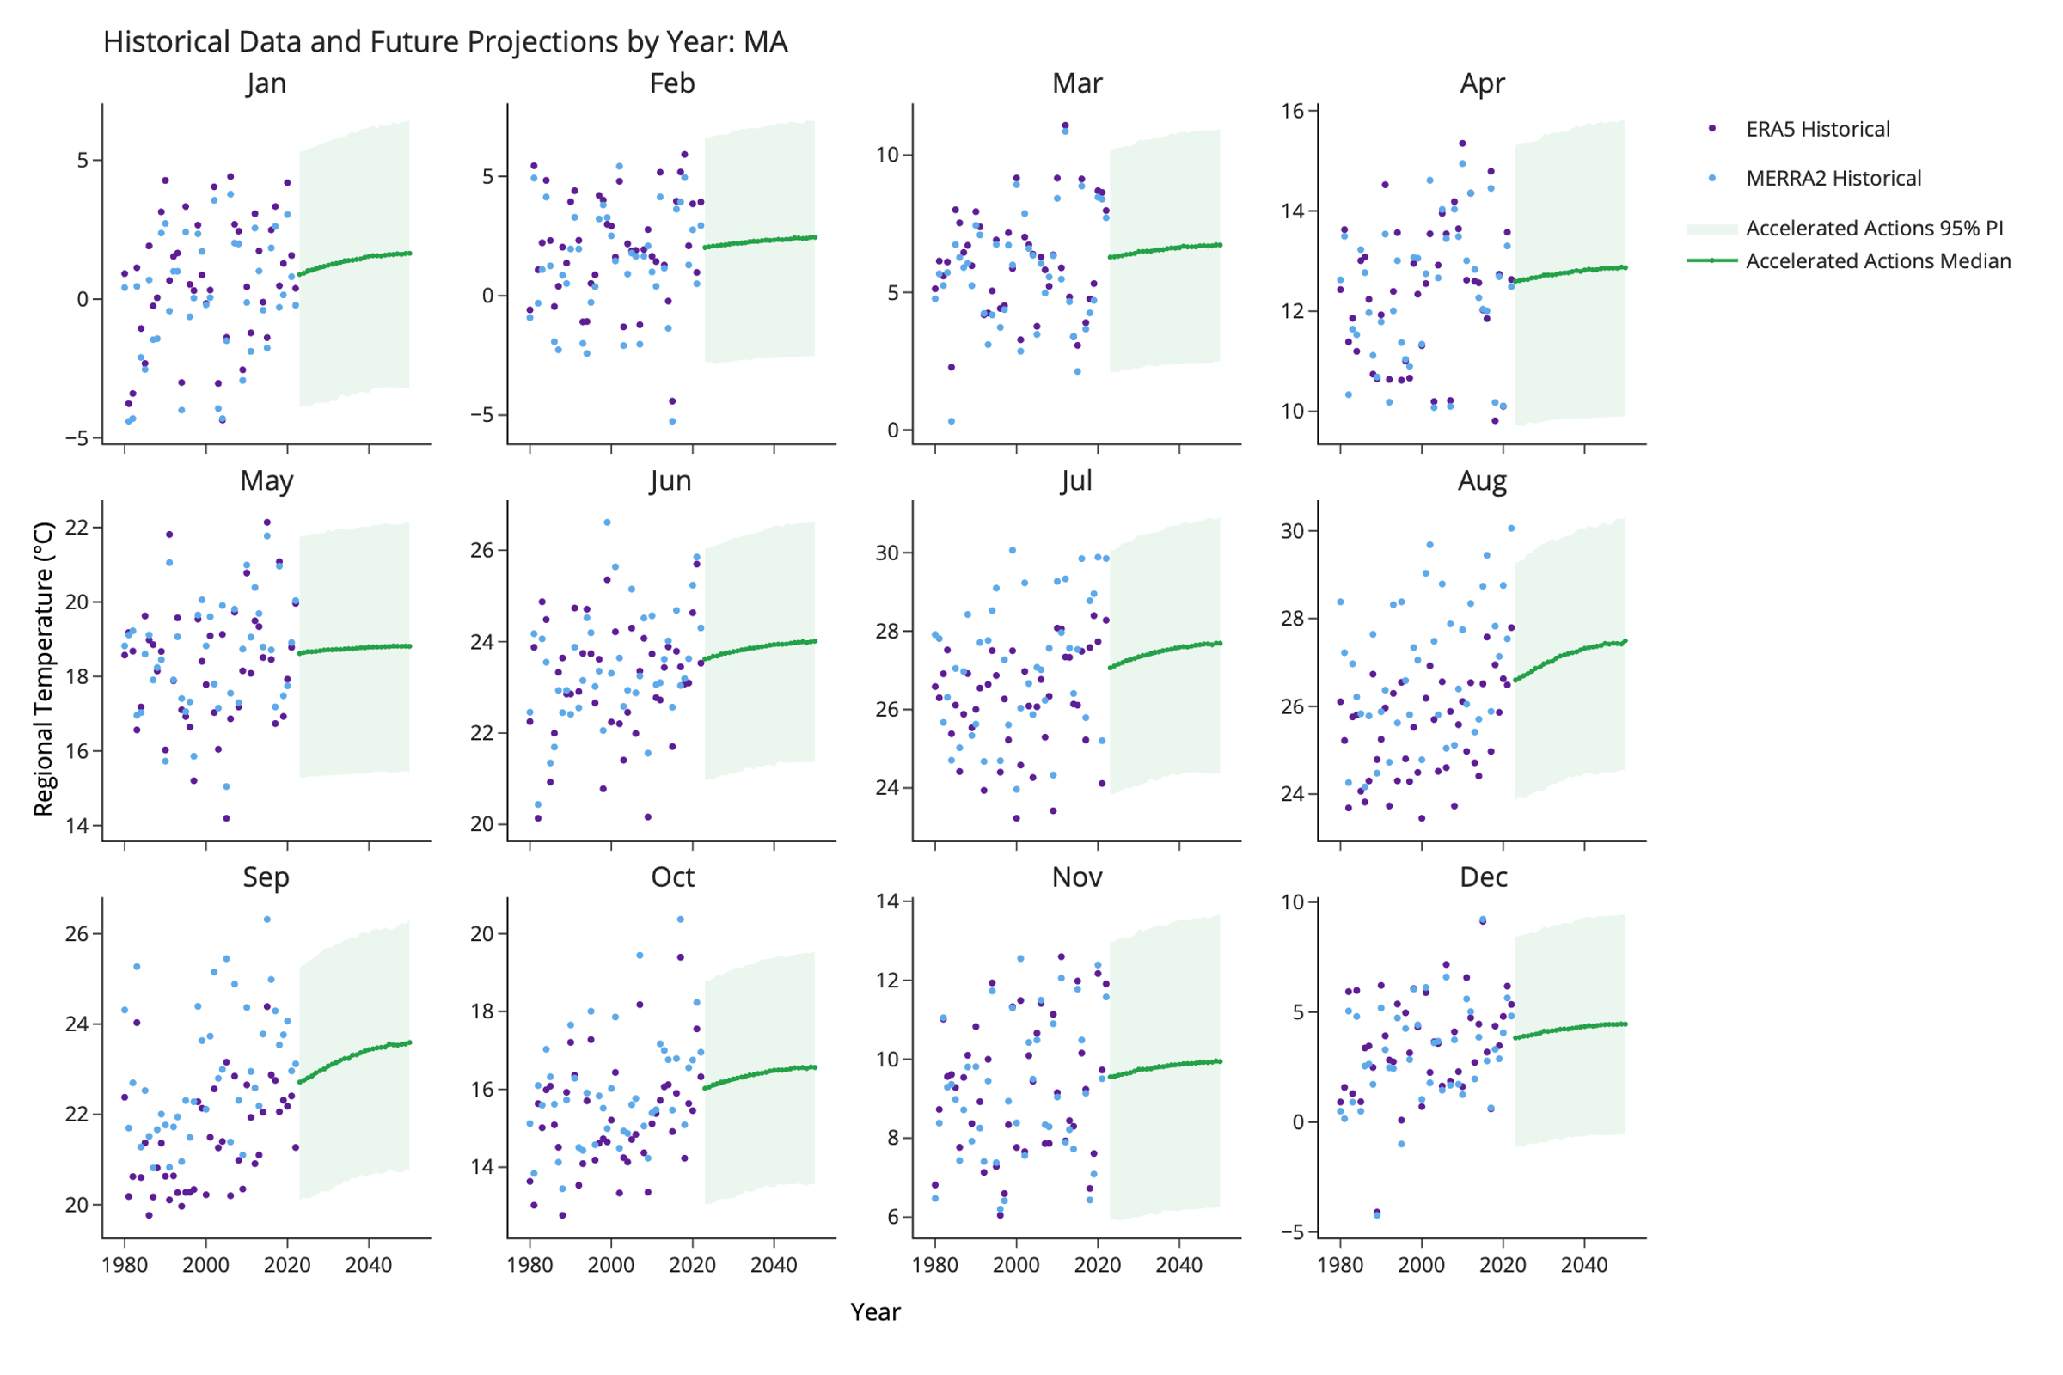
Figure 6. Regression results for Massachusetts also showing projections for the near future (up to 2050) under the Accelerated Actions (policy) scenario in MESM. The uncertainty bounds reflect the middle 95th percentiles of the projections, considering both uncertainty in the regression parameters and uncertainty in the yearly temperature projections. The plots on the left show the projections as a function of average global temperature, while the plots on the right show the projections as a function of year.
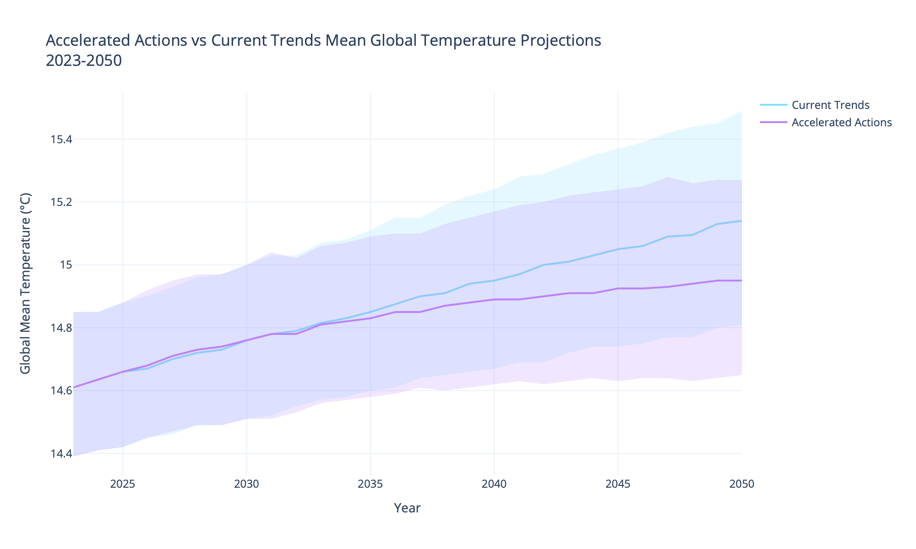
Figure 7. MESM projections for average global temperature through 2050 under a business-as-usual (Current Trends) and policy (Accelerated Actions) scenarios. The shaded regions correspond to the lower 5th percentile and upper 95th percentile of global mean temperature in the MESM ensembles.

Methods
This study combines the regression results of two datasets, ERA5 (ECMWF 2024) and MERRA2 (Global Modeling and Assimilation Office 2015), to provide the most robust estimates for the historical trends and future predictions. For each dataset, a time series of annually, globally averaged temperature was constructed by taking the area-weighted global average of the daily average temperature at 2m height, over the period 1980-2022. Given that one of our goals was to extrapolate local trends out to the future, we settled on using the yearly average global mean temperature as the predictor because it is a standard temperature variable provided by climate and Earth-system predictions. Thus, the framework carries a flexibility to be applied to any such projections (although we use the MESM projections provided by our integrated framework).
Maximum daily temperatures averaged over each month (T_{max, monthly}), separately for each state in the US, were regressed against the global average temperature for the corresponding year (based on data spanning 1980-2022), producing 12 regressions per state, per dataset. The regression slopes and intercepts from each dataset were averaged using an inverse-variance weighted approach (so the dataset with the most variance in the slope/intercept parameters would contribute less to the final model), and those averages are what is reported. To estimate the uncertainty in the regression parameters, we bootstrapped these regressions a total of 500 times. Whenever slopes are reported, they are in the original units (degrees of local monthly-averaged daily maximum temperature change per degree of global warming) unless otherwise indicated. The significance tests for the slopes are Wald tests (Ward and Ahlquist 2018), with the standard errors computed from the slope and intercept inverse variance-weighted averages over the 500 bootstraps.

Webapp
To visualize the uncertainty in the individual regressions, we construct both confidence intervals (capturing only the uncertainty in the predicted mean response) and prediction intervals (capturing the uncertainty for any predicted output value). We used a Monte Carlo procedure to generate projections for entire regression model, including uncertainty from both the global temperature projections and the regression parameters. The 400 future projections of yearly average global temperature from MESM (e.g., Sokolov et al., 2018) were combined with intercept and slope samples from the bootstrapped regressions to produce 1000 forecasts, and the median, 2.5th, and 97.5th percentile values are visualized.
We repeated the same procedure we used to generate the coefficients for the T_{max, monthly} regression to also generate coefficients for monthly-averaged mean and minimum temperatures. We incorporated the uncertainty from both the regression and the projected mean global temperature values in the same way as described above, as well. The webapp thus supports visualizations of projected state monthly max, mean, and min temperatures. The webapp also provides a rough assessment of the warming risk for each state (low, medium, high) based on the average trend across all months. If the state falls in the bottom third of average overall trend, its warming risk is deemed low; if it falls in the middle third, it is deemed medium, and if it falls in the upper third, it is deemed high.
The dashboard uses the Dash package in Python, which enables high interactivity with the plots. Users can show or hide different elements of the plots, such as the historical data or the trend lines, and can download all of the plots.

Data Records
- Mention data availability once it’s determined where the data will be stored
- Use svante

Technical Validation
Our raw data is pulled from the MERRA-2 and ERA5 datasets; both have been independently and comprehensively validated as reliable (Hersbach et al. 2020; Luo et al. 2020). The R² values from our regressions are given in Supplementary Figure 1.
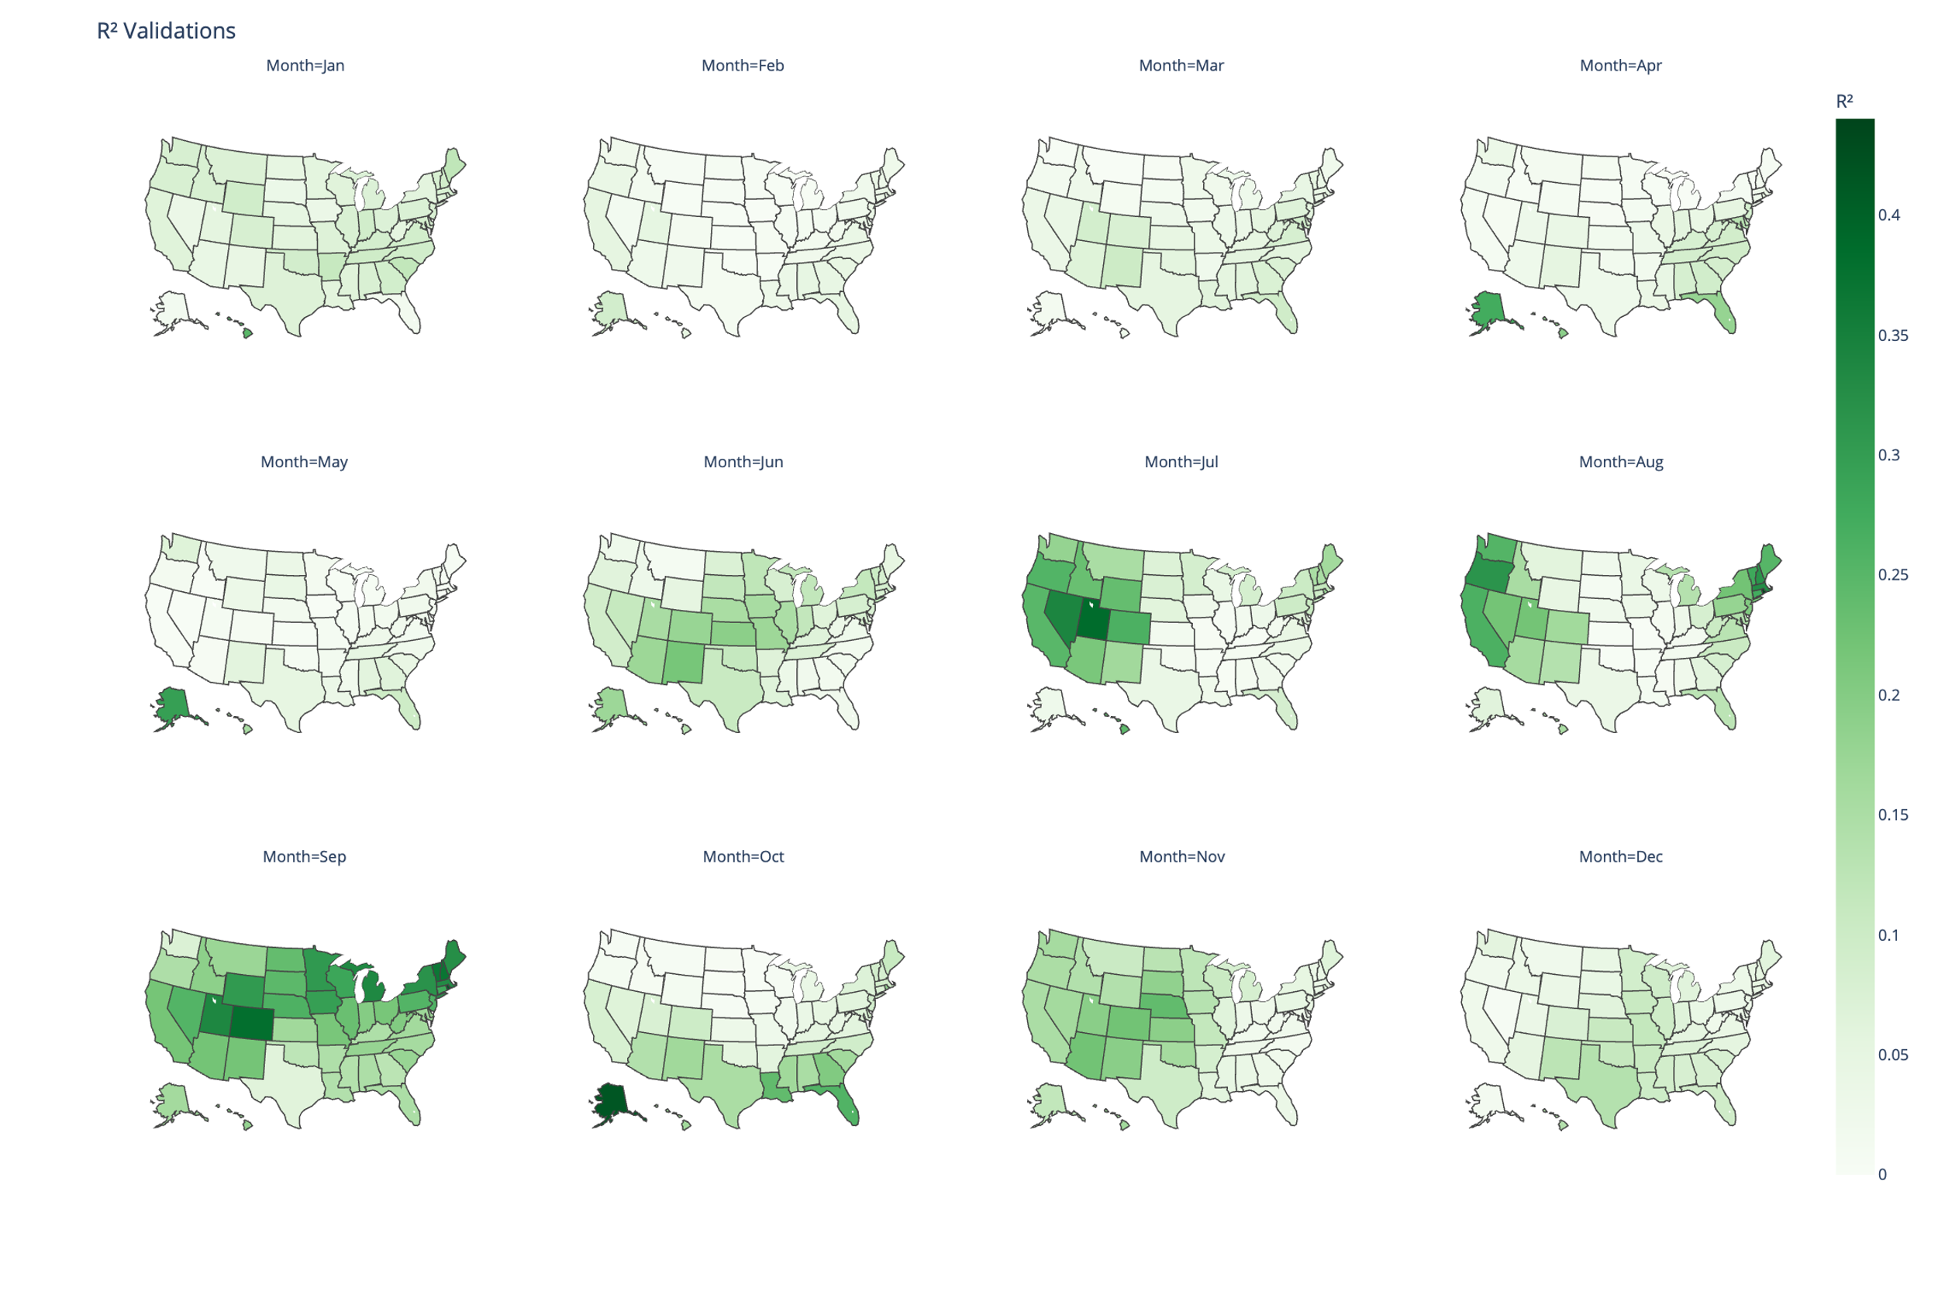
Supplementary Figure 1. Validation of regression results. R^2 values were obtained by squaring the Pearson r coefficient between the predicted local temperatures and historical local temperatures across all states for each dataset, and averaging the values.

Code Availability
The code used for the plots and analysis is available on Github: https://github.com/TheKenster1729/Climate-Extremes-Forecasting/tree/main

References
Arthur, David, and Sergei Vassilvitskii. 2006. “K-Means++: The Advantages of Careful Seeding.” Techreport. Stanford, June 7. http://ilpubs.stanford.edu:8090/778/?ref=https://githubhelp.com.
Carvalho, M. J., P. Melo-Gonçalves, J. C. Teixeira, and A. Rocha. 2016. “Regionalization of Europe Based on a K-Means Cluster Analysis of the Climate Change of Temperatures and Precipitation.” Physics and Chemistry of the Earth, Parts A/B/C, 3rd International Conference on Ecohydrology, Soil and Climate Change, EcoHCC’14, vol. 94 (August): 22–28. https://doi.org/10.1016/j.pce.2016.05.001.
Collins, M., R. Knutti, J. Arblaster, et al. 2013. Chapter 12 - Long-Term Climate Change: Projections, Commitments and Irreversibility. Edited by IPCC. With M. R. Allen, T. Andrews, U. Beyerle, et al. Cambridge University Press. http://www.climatechange2013.org/images/report/WG1AR5_Chapter12_FINAL.pdf.
Copernicus Climate Change Service (C3S) Climate Data Store (CDS). 2024. “ERA5 Post-Processed Daily-Statistics on Single Levels from 1940 to Present.” https://doi.org/10.24381/cds.4991cf48.
Dai, Shuwei, Martha Shulski, Kenneth Hubbard, and Eugene Takle. 2016. “A Spatiotemporal Analysis of Midwest US Temperature and Precipitation Trends during the Growing Season from 1980 to 2013.” School of Natural Resources: Faculty Publications, January 1. https://digitalcommons.unl.edu/natrespapers/626.
Fujiwara, Masatomo, Jonathon S. Wright, Gloria L. Manney, et al. 2017. “Introduction to the SPARC Reanalysis Intercomparison Project (S-RIP) and Overview of the Reanalysis Systems.” Atmospheric Chemistry and Physics 17 (2): 1417–52. https://doi.org/10.5194/acp-17-1417-2017.
Gao, Xiang, C. Adam Schlosser, and Eric R. Morgan. 2018. “Potential Impacts of Climate Warming and Increased Summer Heat Stress on the Electric Grid: A Case Study for a Large Power Transformer (LPT) in the Northeast United States.” Climatic Change 147 (1–2): 107–18. https://doi.org/10.1007/s10584-017-2114-x.
García, Francisca C., Elvire Bestion, Ruth Warfield, and Gabriel Yvon-Durocher. 2018. “Changes in Temperature Alter the Relationship between Biodiversity and Ecosystem Functioning.” Proceedings of the National Academy of Sciences 115 (43): 10989–94. https://doi.org/10.1073/pnas.1805518115.
Global Modeling and Assimilation Office (GMAO). n.d. “Modern-Era Retrospective Analysis for Research and Applications, Version 2.” https://doi.org/10.5067/9SC1VNTWGWV3.
Grotjahn, Richard, and Jonathan Huynh. 2018. “Contiguous US Summer Maximum Temperature and Heat Stress Trends in CRU and NOAA Climate Division Data plus Comparisons to Reanalyses.” Scientific Reports 8 (1): 11146. https://doi.org/10.1038/s41598-018-29286-w.
Hayhoe, Katharine, Cameron Wake, Bruce Anderson, et al. 2008. “Regional Climate Change Projections for the Northeast USA.” Mitigation and Adaptation Strategies for Global Change 13 (5): 425–36. https://doi.org/10.1007/s11027-007-9133-2.
Hersbach, Hans, Bill Bell, Paul Berrisford, et al. 2020. “The ERA5 Global Reanalysis.” Quarterly Journal of the Royal Meteorological Society 146 (730): 1999–2049. https://doi.org/10.1002/qj.3803.
Kim, Yesuel, and Youngchul Kim. 2023. “Global Regionalization of Heat Environment Quality Perception Based on K-Means Clustering and Google Trends Data.” Sustainable Cities and Society 96 (September): 104710. https://doi.org/10.1016/j.scs.2023.104710.
Lee, Hoesung, Katherine Calvin, Dipak Dasgupta, et al. 2023. “Synthesis Report of the IPCC Sixth Assessment Report (AR6), Longer Report. IPCC.” Monograph. Intergovernmental Panel on Climate Change (IPCC). https://mural.maynoothuniversity.ie/17733/.
Luo, Bingkun, Peter J. Minnett, Malgorzata Szczodrak, Nicholas R. Nalli, and Vernon R. Morris. 2020. Accuracy Assessment of MERRA-2 and ERA-Interim Sea Surface Temperature, Air Temperature, and Humidity Profiles over the Atlantic Ocean Using AEROSE Measurements. Journal of Climate. August 15. https://doi.org/10.1175/JCLI-D-19-0955.1.
Molina, M. O., C. Gutiérrez, M. Ortega, and E. Sánchez. 2023. “Summer Heatwaves, Wind Production and Electricity Demand in Southern Europe: Climatic Conditions and Impacts.” Environmental Research Communications 5 (8): 085005. https://doi.org/10.1088/2515-7620/acec37.
Portmann, Robert W., Susan Solomon, and Gabriele C. Hegerl. 2009. “Spatial and Seasonal Patterns in Climate Change, Temperatures, and Precipitation across the United States.” Proceedings of the National Academy of Sciences 106 (18): 7324–29. https://doi.org/10.1073/pnas.0808533106.
Powell, Emily J., and Barry D. Keim. 2015. Trends in Daily Temperature and Precipitation Extremes for the Southeastern United States: 1948–2012. Journal of Climate. February 15. https://doi.org/10.1175/JCLI-D-14-00410.1.
Sathiaraj, D., X. Huang, and J. Chen. 2019. “Predicting Climate Types for the Continental United States Using Unsupervised Clustering Techniques.” Environmetrics 30 (4): e2524. https://doi.org/10.1002/env.2524.
Sokolov, Andrei, David Kicklighter, Adam Schlosser, et al. 2018. “Description and Evaluation of the MIT Earth System Model (MESM).” Journal of Advances in Modeling Earth Systems 10 (8): 1759–89. https://doi.org/10.1029/2018MS001277.
Tavakol, Ameneh, Vahid Rahmani, and John Harrington. 2020. “Evaluation of Hot Temperature Extremes and Heat Waves in the Mississippi River Basin.” Atmospheric Research 239 (July): 104907. https://doi.org/10.1016/j.atmosres.2020.104907.
Ward, Michael D., and John S. Ahlquist. 2018. Maximum Likelihood for Social Science: Strategies for Analysis. Cambridge University Press.
Wheeler, Timothy R, Peter Q Craufurd, Richard H Ellis, John R Porter, and P. V Vara Prasad. 2000. “Temperature Variability and the Yield of Annual Crops.” Agriculture, Ecosystems & Environment 82 (1): 159–67. https://doi.org/10.1016/S0167-8809(00)00224-3.
Acknowledgements
The authors thank Popat Salunke at the MIT Center for Sustainability Science and Strategy for providing the projections of global average temperature from the MESM model. [Grant information?]

Author information
MIT Center for Sustainability Science and Strategy
Kenneth L. Cox, C. Adam Schlosser, Jennifer Morris, Xiang Gao

Ethics declarations
Competing Interests
The authors declare no competing interests.

Supplementary information
In Figure 3, we presented results of a clustering analysis that enables an efficient visualization of which states contain the most similar temperature change patterns. Because the k-means algorithm used to create the clusters has random (although optimized) initialization using the k-means++ initialization algorithm (Arthur and Vassilvitskii 2006), there may be slightly different clustering results as the number of clusters is changed, and even within the same number of clusters. The randomness within the same number of clusters is accounted for by running k-means 10 times and choosing clusters based on which initial cluster centroids achieve the most stable results. The robustness of k-means with respect to the number of clusters is examined in Supplementary Figure 2, which contains clustering results using the same setup, differing only in the number of clusters selected (4 and 5).
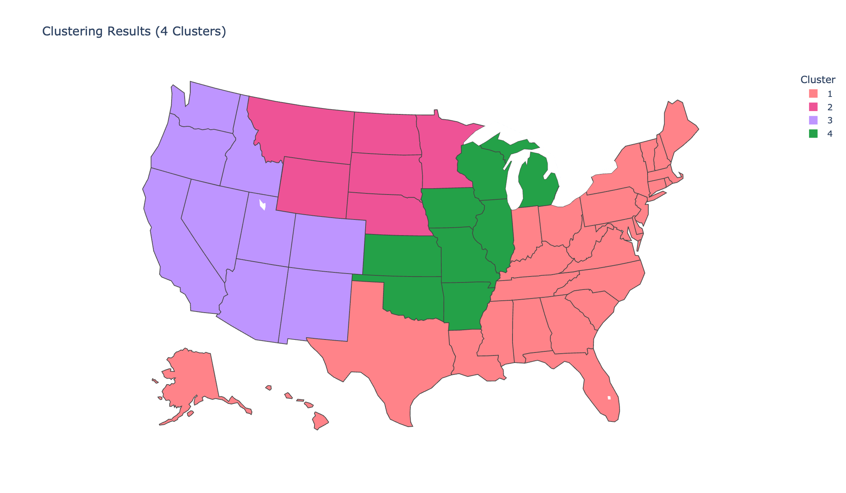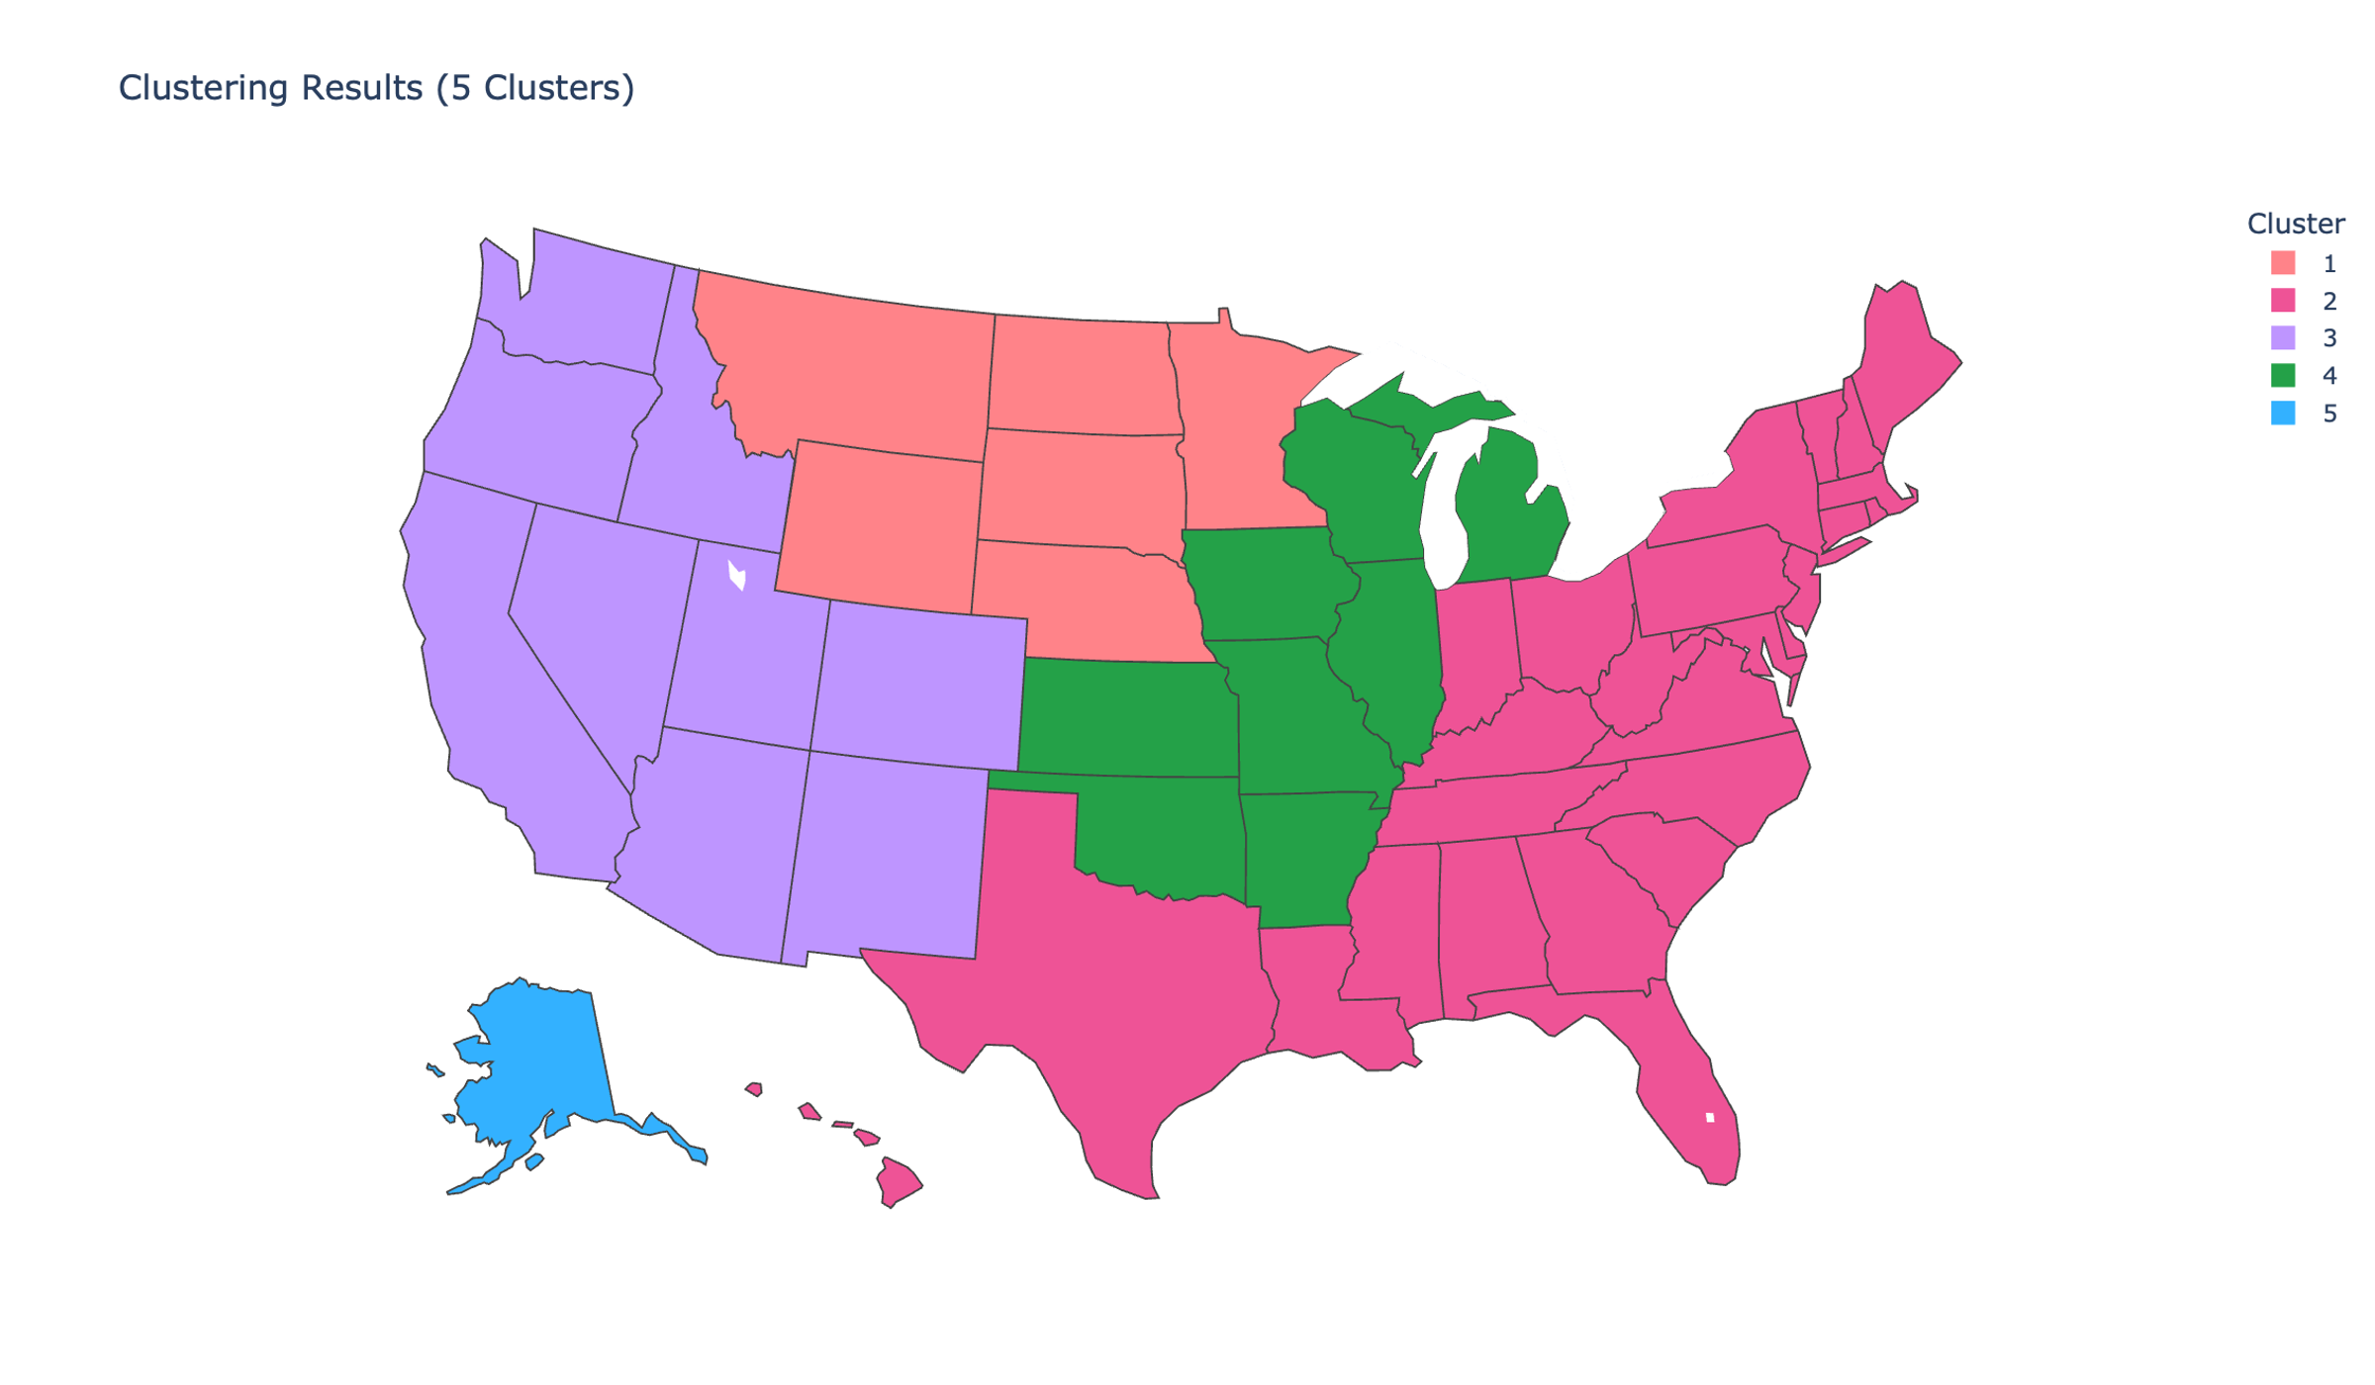
Supplementary Figure 2. Robustness of k-means clustering results to the number of clusters; the map to the left shows clustering results when the number of clusters is set to 4, and the map to the left shows the same when the number of clusters is set to 5.
While the clusters show groupings of similar states, they do not say how those states are similar. The boxplots in Supplementary Figure 3 provide a comprehensive overview of the summary statistics of the clusters.
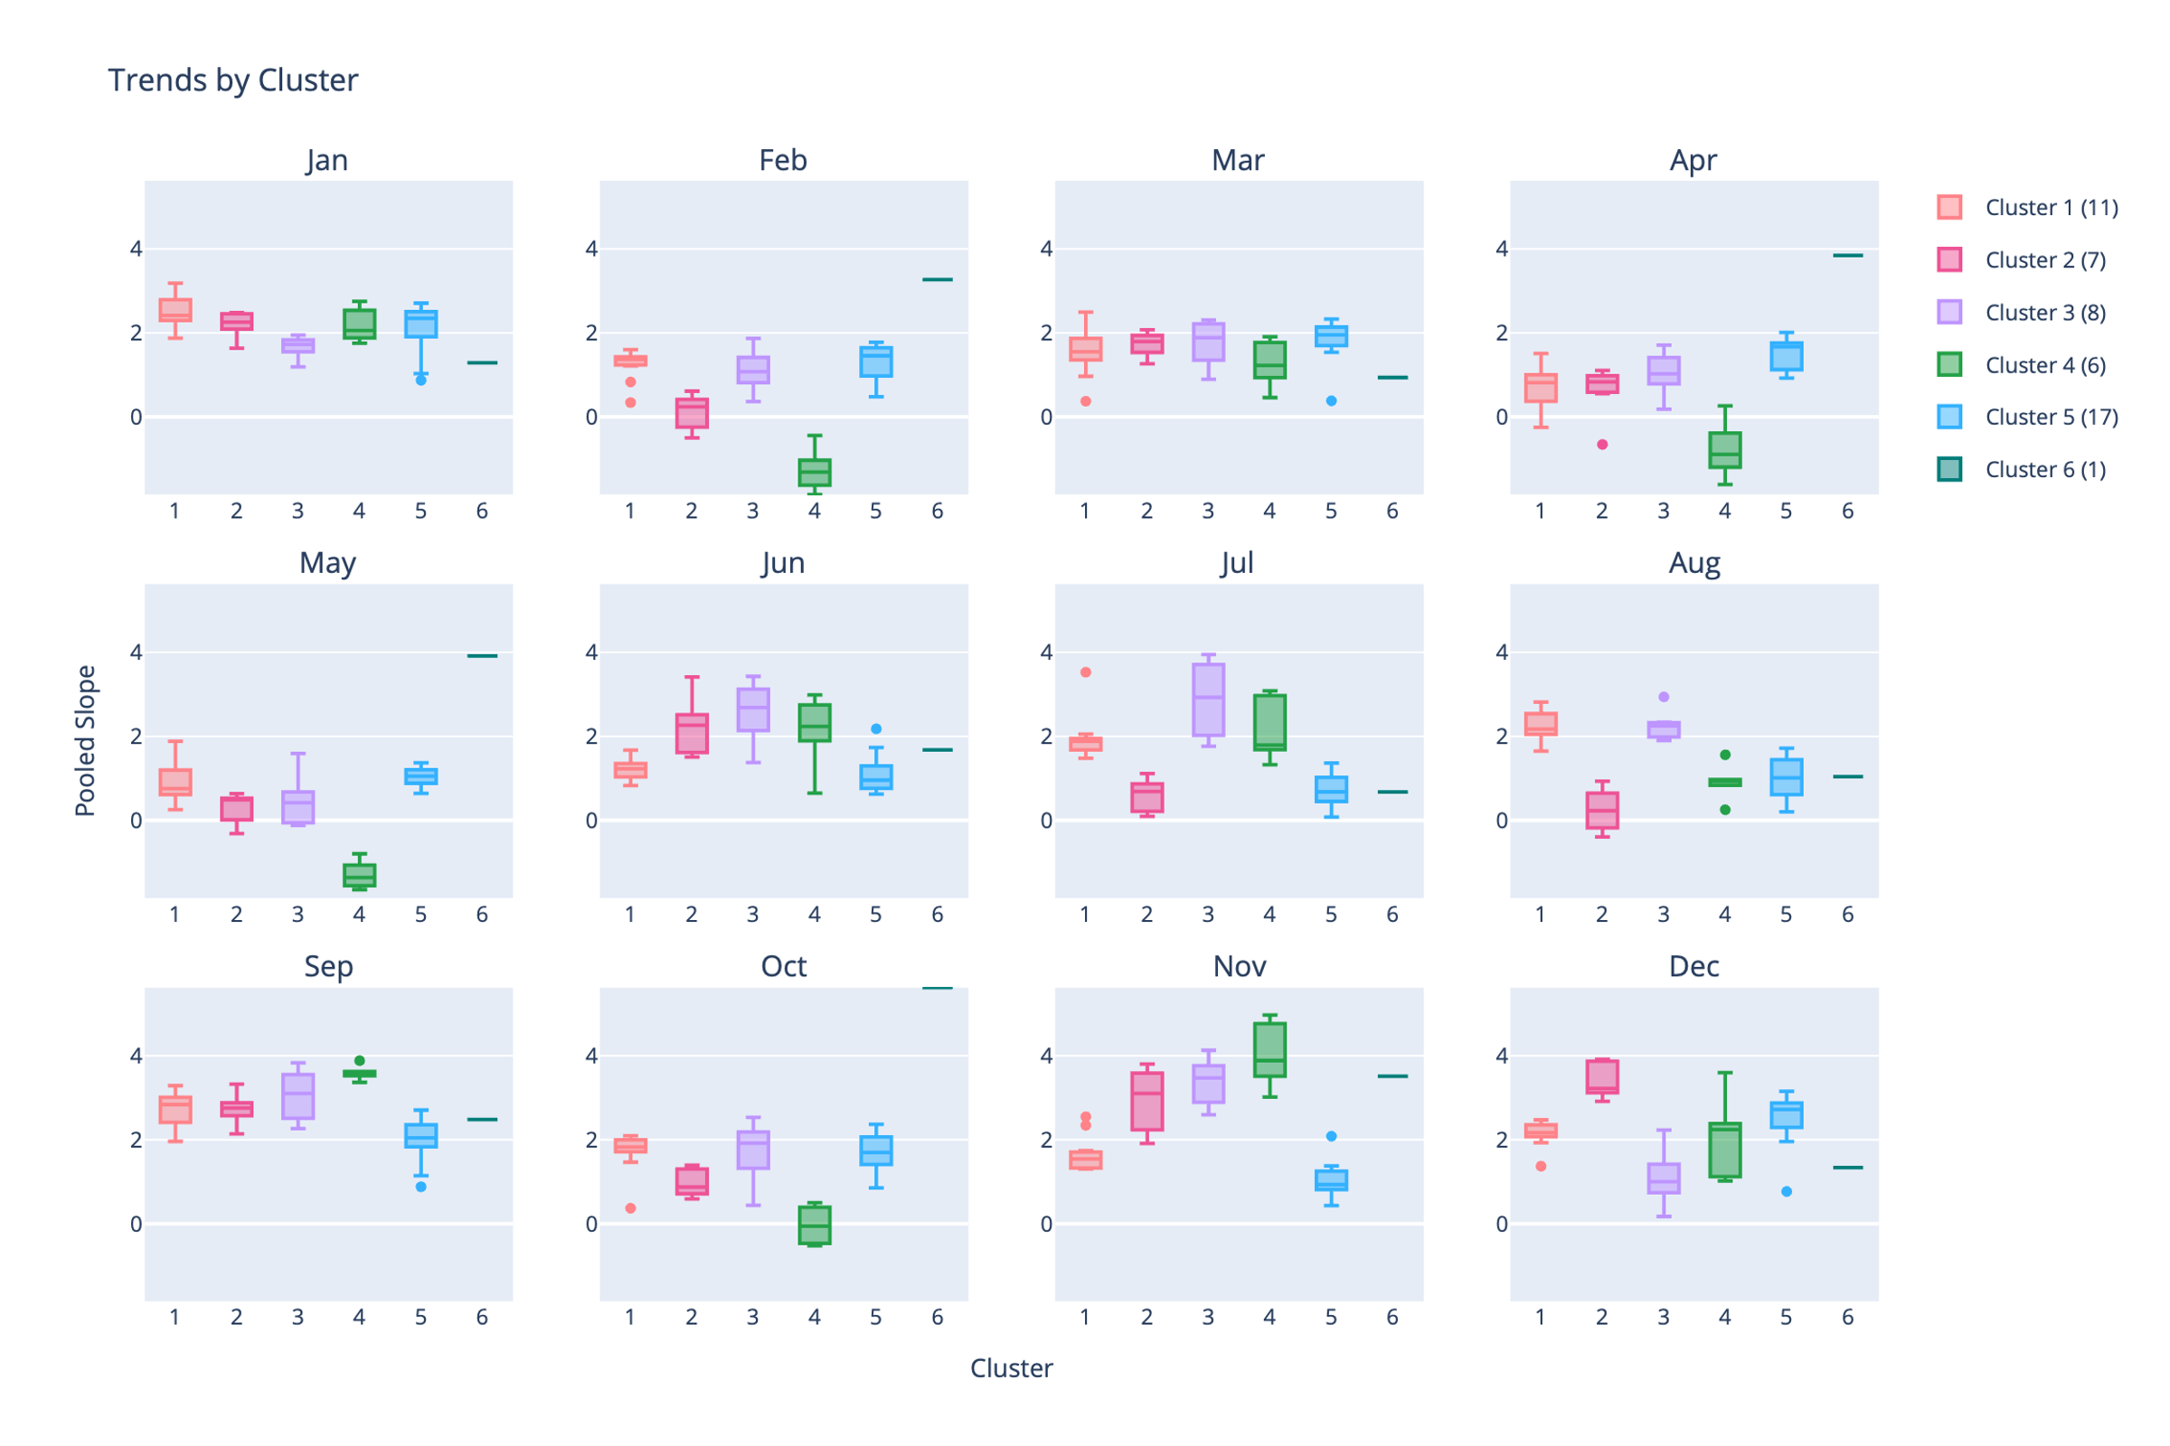
Supplementary Figure 3. Boxplots showing distribution summaries of each of the clusters from Figure 2 (reproduced here).

